Task :
=====
- Create a cluster
First, we must launch the ec2 instance after logging into the server. we need the download the EKSCTL following the below link https://www.eksworkshop.com/030_eksctl/prerequisites/
Prerequisite :
==========
Helm install in our ec2 instance https://docs.aws.amazon.com/eks/latest/userguide/helm.html
Awscli:https://docs.aws.amazon.com/cli/latest/userguide/getting-started-install.html
Kubectl:https://kubernetes.io/docs/tasks/tools/
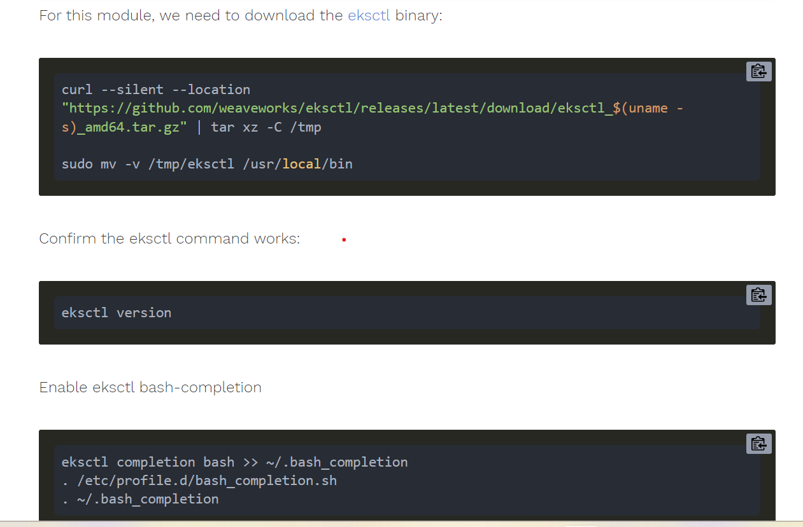

Create an eksctl deployment file (eksworkshop.YAML)

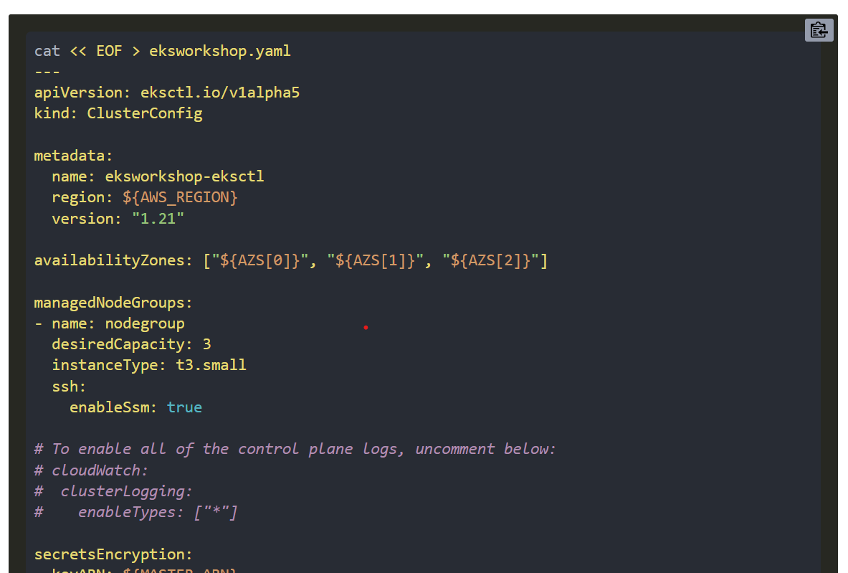

We will change the eksworkshop—yaml file to mention the region name and availability zones.
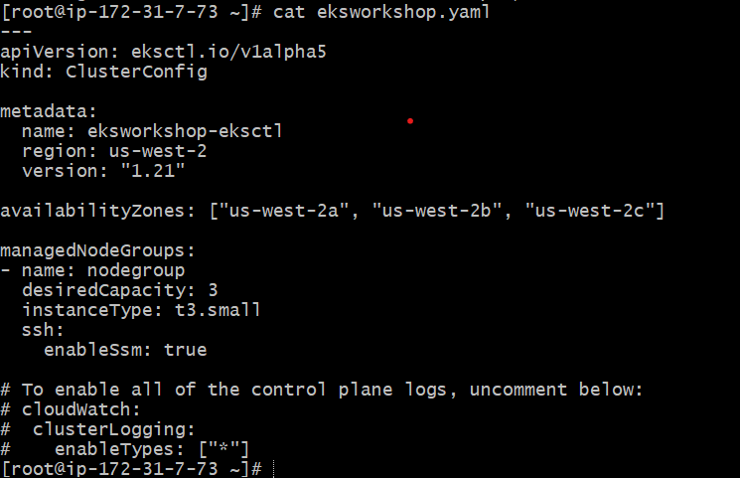

After that, we enter the command and create the cluster.
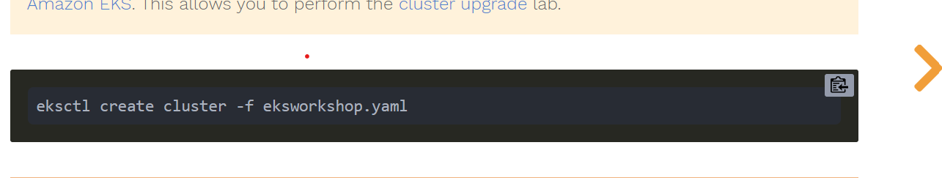

After the create the cluster update the .kubeconfig

Aws eks – region <name> update-kubeconfig –name <clustername>

If not working the kubectl command we will update the awscli if go through refer to the below link
https://stackoverflow.com/questions/72126048/circleci-message-error-exec-plugin-invalid-apiversion-client-authentication

Once update the awscli again .kubeconfig file update its working or not check it the kubectl command.
I enter the command: kubectl get nodes

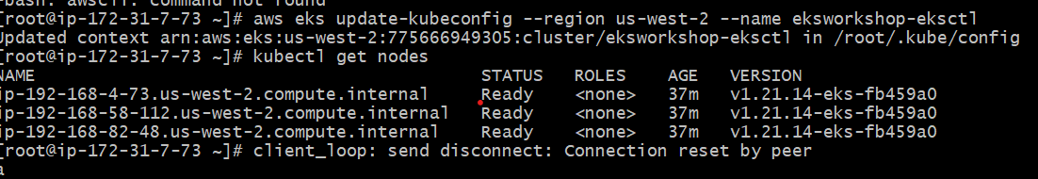

2. Task
======
Prometheus and grafana deploy to eks-cluster

Prometheus and grafana deploy the eks following the link :
https://www.eksworkshop.com/intermediate/240_monitoring/deploy-prometheus/

First, we install the helm :
https://docs.aws.amazon.com/eks/latest/userguide/helm.html
After we enter the below commands
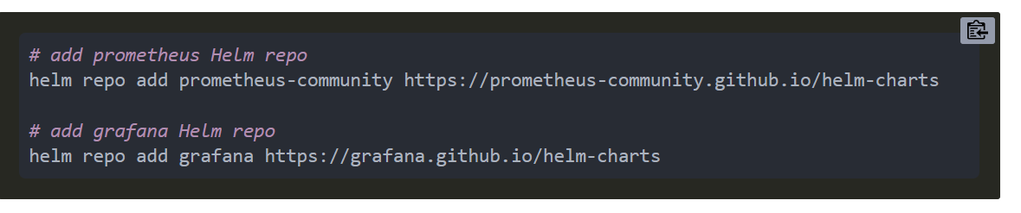

After we deploy the Prometheus :
https://www.eksworkshop.com/intermediate/240_monitoring/deploy-prometheus/
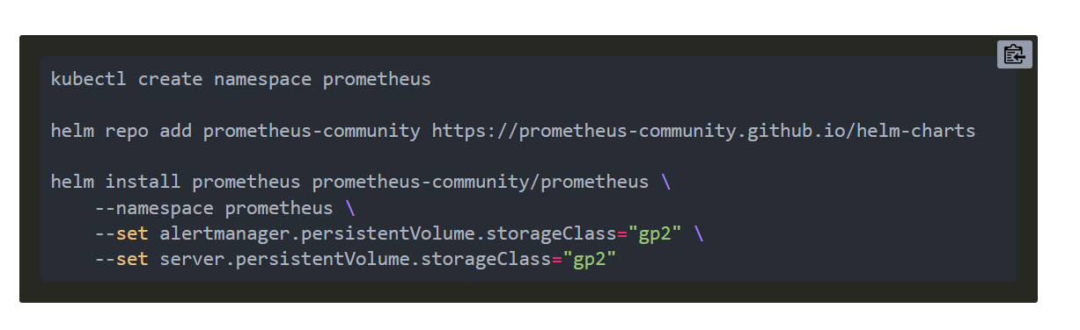
After that we enter the command: kubectl get all -n prometheus

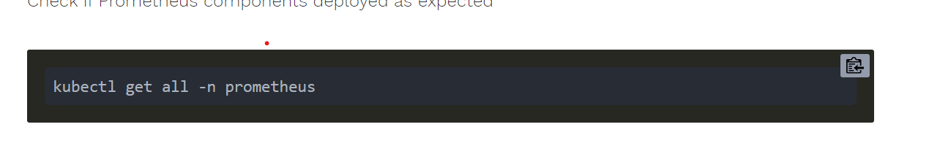

We get the output :
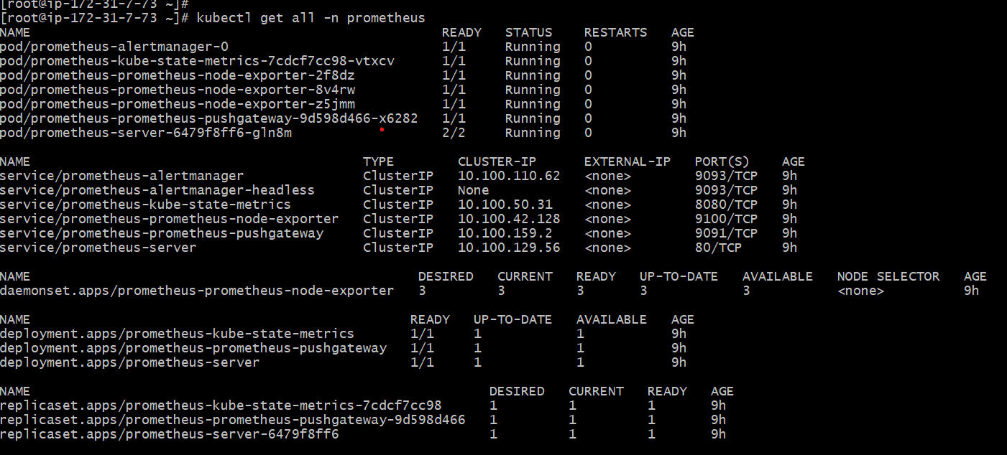

I want to change the svc yaml file and insert the LoadBalancer type
Commands:
Kubectl get svc -n prometheus
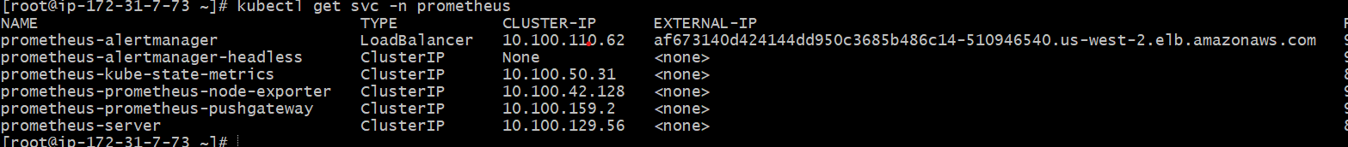
Kubectl edit svc -n prometheus
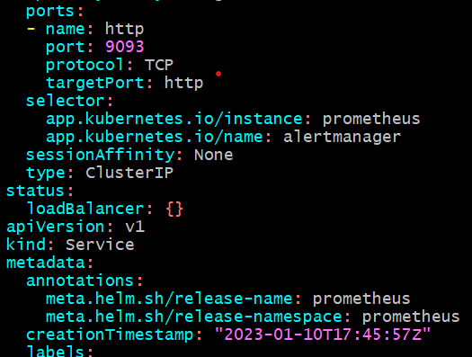

I want to change the type in insert the LoadBalancer

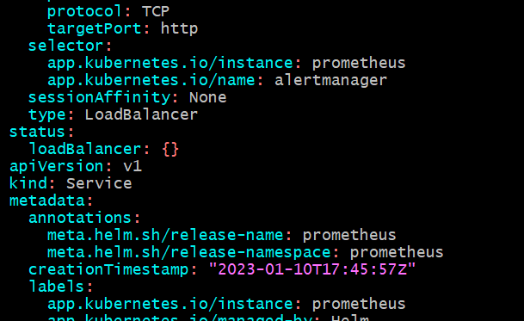

After we enter the command: kubectl get all -n Prometheus it will show the output
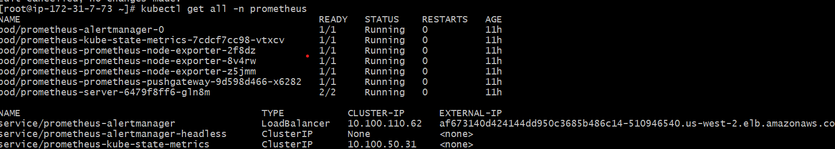

Again we deploy the grafana :
https://www.eksworkshop.com/intermediate/240_monitoring/deploy-grafana/

First, we have create the namespace grafana :kubectl create ns grafana
Garafana namespace is coming or not we check the command
Kubectl get ns
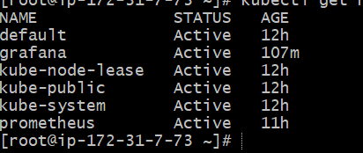

After that we create the directory command: mkdir environment/grafana
To insert the content the grafana.yaml
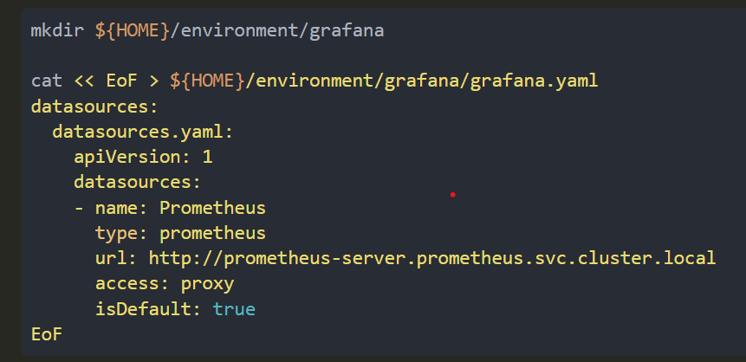

After we enter the command :
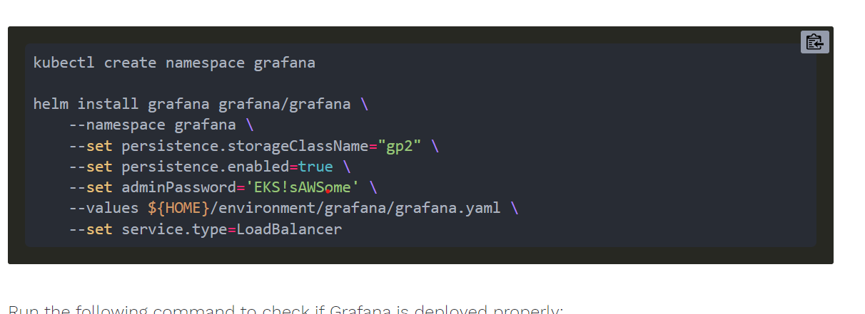
Change the adminpassword
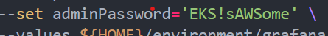

Deploy the grafana command: kubectl get all -n grafana
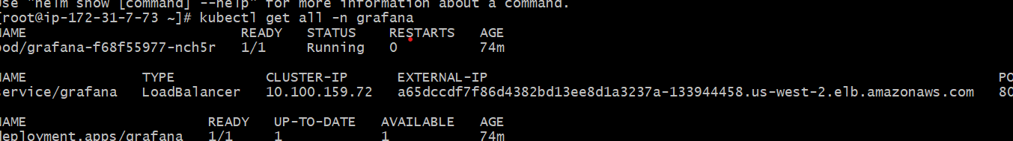
Copy the External-IP search in the browser it will come grafana page.

3. Task
======
3) create a custom dashboard to monitor CPU memory
--> create three variables
Cluster name, namespace name, pod names

First, we have to log in to grafana after that we select that== DASHBOARD ====NEW Dashboard===add new panel.

After that, we write the query: CPU

Container_cpu_usage_seconds_total{} and run query ==save==
apply
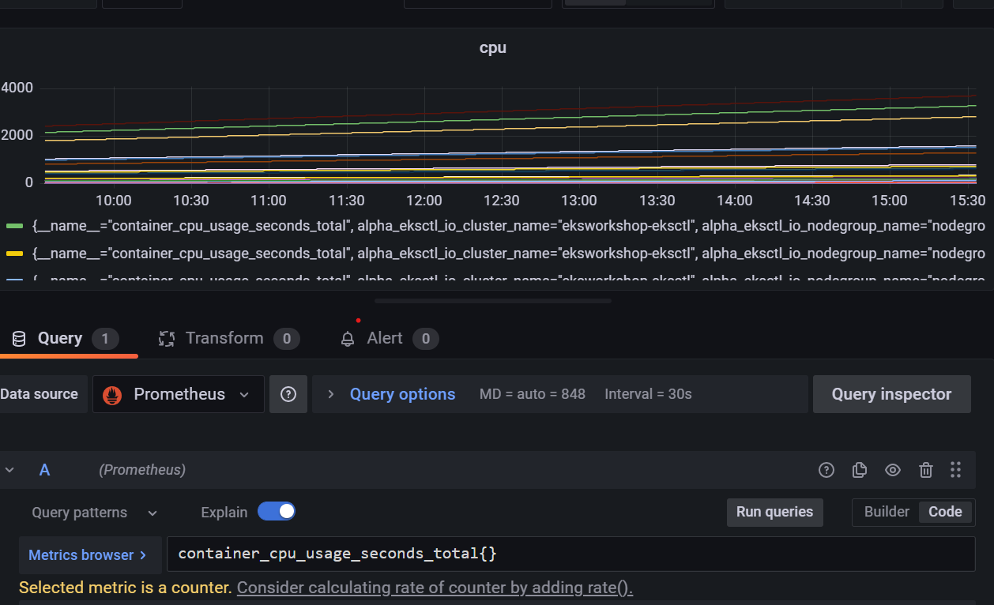

The same process added a new dashboard after the memory query
Memory query :
Container_memory_working_set_bytes{} after run query ==save==apply
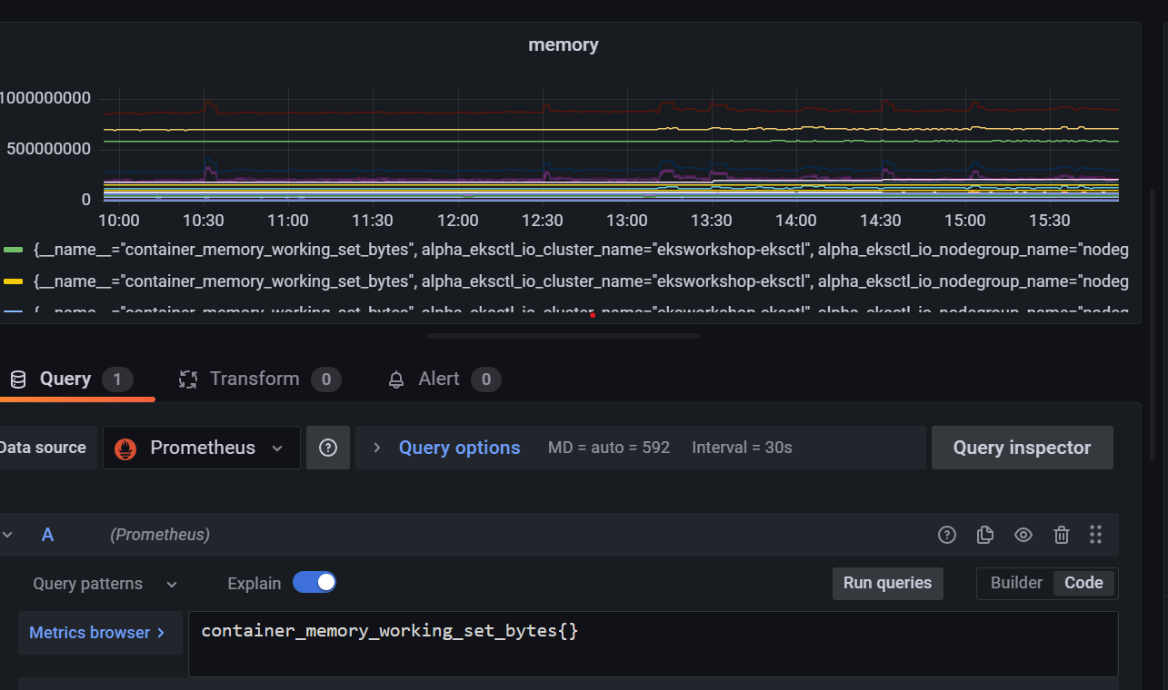

Dashboard CPU And Memory:
=========================

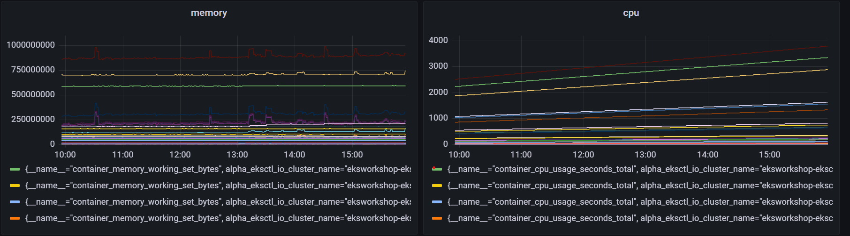

Create three variables :
=====================

Go to the Dashboard setting====varialbles ===+new variable=we write the variable name after we apply that
